April 5, 2024

To Whom It May Concern:

On behalf of Safari Club International (SCI), I write to you in strong opposition to Senate Bill 238. SCI is dedicated to protecting the freedom to hunt and promoting wildlife conservation worldwide. Our organization, along with our active members, are deeply concerned about the potential changes the legislation would have on the structure and authority of the Vermont Fish and Wildlife Board.

Senate Bill 258 would fundamentally overhaul the 14-member Vermont Fish and Wildlife Board by removing its rulemaking authority and, instead, make it merely an advisory body to the Vermont Fish and Wildlife Department. If passed, the Commissioner of the Department would then have final authority over rules and regulations.

These changes are deeply troubling and are emblematic of larger trends across the country where anti-hunters and those opposed to science-based, consumptive use of wildlife work to infiltrate game and fish commissions in order to limit certain activities.

This approach in antithetical to the incredibly successful American System of Conservation Funding and the North American Model of Wildlife Conservation, both of which are central to the resurgence of wildlife populations and science-based wildlife management in the 20th century and continuing today.

Importantly, sportsmen and women are the primary funders of wildlife conservation nationwide and in Vermont. Through the sale of hunting and fishing licenses and tags, as well as associated excise taxes on firearms, ammunition, fishing equipment, and other outdoor items paid by manufacturers, hunters and anglers help to drive the funds needed for the Department to provide on the ground conservation delivery/habitat improvement (for game and non-game), increase access to public lands and waters, general Department operations, and more.

The North American Model of Wildlife Conservation holds that, among other things, wildlife decisions must be based on science and that proper use of wildlife resources is dictated by law to be managed by the respective state or federal government agency. The current Vermont Fish and Wildlife Board structure, appointment process, and actions as a regulatory body have been highly effective and successful for the people of Vermont.

Thank you for your time and consideration of this important measure, and we respectfully ask for your opposition to Senate Bill 238.

Sincerely,
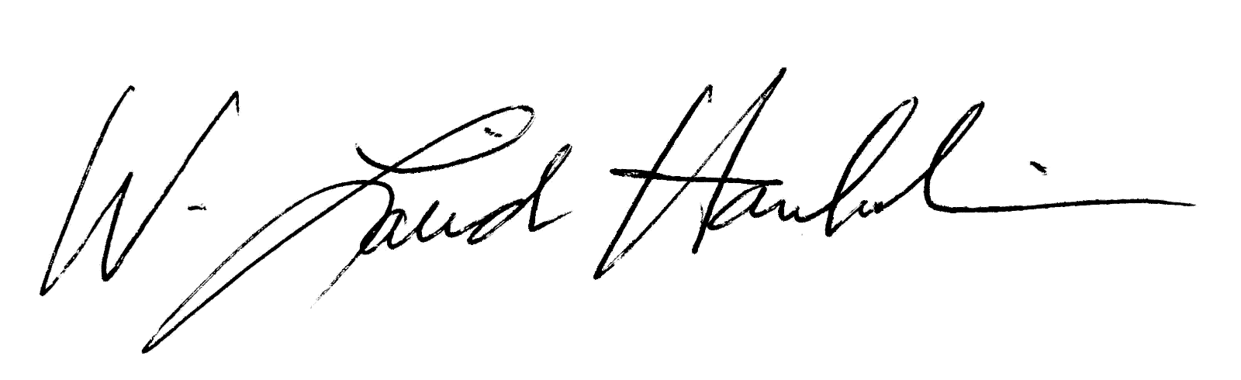

W. Laird Hamberlin, CEO – Safari Club International/Foundation

